Ahmad Barakat | ITEC 454 | 04/19/2025

Business Impact Analysis (BIA): Initech Technologies

Organizational Mission Statement

Initech Technologies provides innovative software solutions and IT consulting services to aid clients in optimizing business processes, improving customer engagement, and advancing in digital transformation. It is also essential to maintain the safety and security of all employees and customers alike.

Essential Business Functions

Business Function | Description | How it supports the organization
Software Development | Design, build, and deploy specific software for clients | Primary source of revenue, fulfills core mission of software solutions.
Client Support Services | Provide technical support through ticketing system, phone and live chat. | Client satisfaction, and customer retention.
Cloud Infrastructure | Manage cloud hosting, deployments, and backups. | Keep client systems secure online.
Internal IT/Network Admin | Maintain systems, employee devices, and network access. | Support employee productivity and secure work environment.
Human Resources | Hiring, employee records, and compensation | Ensure compliance, staff retention

Recovery Time/Point Objectives

Recovery Time Objective (RTO): How fast Initech Technologies will need to get the system back up (2022).

Recovery Point Objective (RPO): How much data Initech can afford to lose.

Priority: Level of importance to the operations of the company and data sensitivity.

Business Function | Recovery Time Objective (RTO) | Recovery Point Objective | Priority (High = 1, Low = 5)
Software Development | 8 Hours | 2 Hours | 1
Cloud Infrastructure | 8 Hours | 1 Hour | 2
Client Support Services | 16 Hours | 4 Hours | 3
Internal IT/Network Admin | 24 Hours | 8 Hours | 4
Human Resources | 48 Hours | 24 Hours | 5

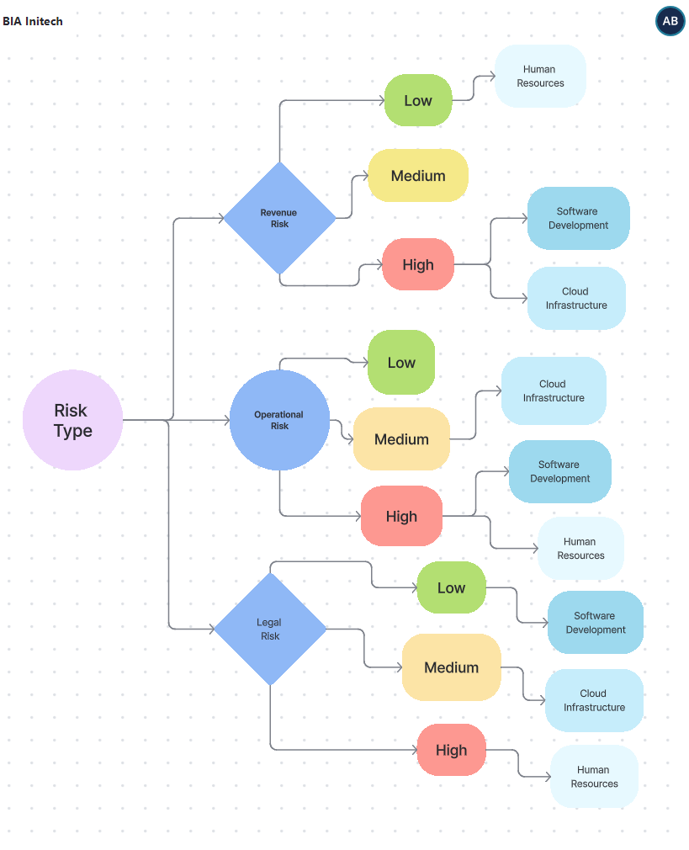
Risk Illustration

Resources

NIST SP 800-34. NIST. (2021, April 23). https://www.nist.gov/privacy-framework/nist-sp-800-34
Wilson, M. (2022). Establishing RPO and RTO targets for cloud applications. https://aws.amazon.com/blogs/mt/establishing-rpo-and-rto-targets-for-cloud-applications

